UCD School of Electrical, Electronic & Communications Engineering



EEEN 30020 Circuit Theory

Signed: _______________________ _________________________

Date: _________________________ _________________________

Lab 3 Circuit Theory Report

*Hugh Gowing 13369666 Fergal Lonergan 13456938*

**Declaration: We declare that the work described in this report was done by the persons named above, and that the description and comments in this report are our own work, except where otherwise acknowledged. We have read and understand the consequences of plagiarism as discussed in the EECE School Policy on Plagiarism, the UCD Plagiarism Policy and the UCD Briefing Document on Academic Integrity and Plagiarism. We also understand the definition of plagiarism.**

Lab 3 Circuit Theory Report

**Objective:**

Design, simulation and measurement of a Sallen-Key third-order Butterworth low-pass filter

# Design

## Does the order of this cascade matter?

Mathematically, it does not matter in which order the sections are placed - the result will be the same as the transfer function will be the same. This assumes that there are no errors. In practice, the propagation of errors is crucial to the success of some filters so the order of the sections in the cascade form can be vital.

## In a cascade configuration, a first-order filter is typically followed by a buffer. Why is this? How is such a buffer realised?

It is commonly followed by a noninverting buffer amplifier to prevent loading by the circuit following the filter, which could alter the filter response. In addition, the buffer can provide some drive capability.  
The buffer is realized by the transfer function equal to:

1 + $\frac{R_{B}}{R_{A}}$

This can be realized by the circuit below involving an op-amp and two resistors where R6 is equal to $R_{B}$ and R7 is equal to $R_{A}$.  
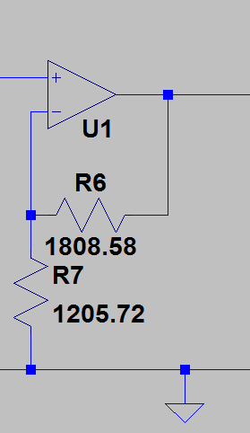

# Simulation in LTspice

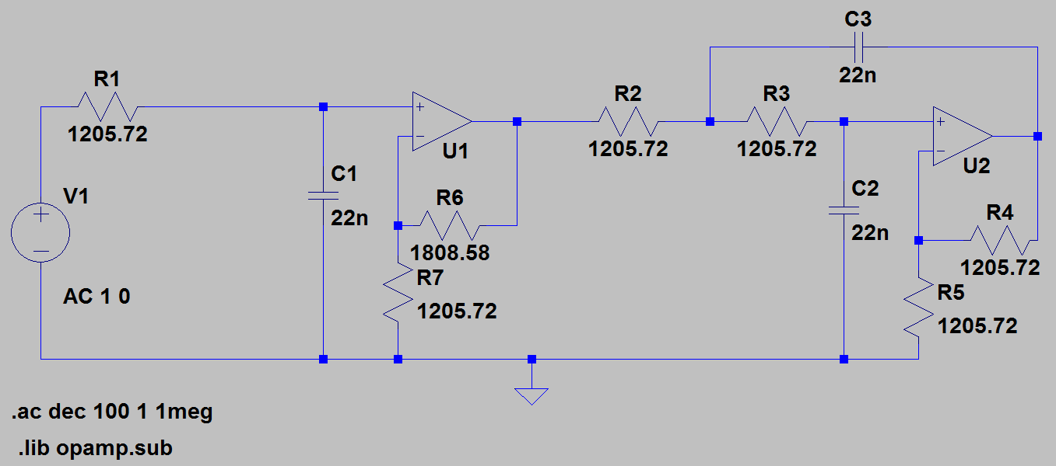

## Are these responses as expected?

## 

Yes the responses are expected and follow the typical shape of a third order Butterworth-Response filter.

## At what frequency is the 3dB point?

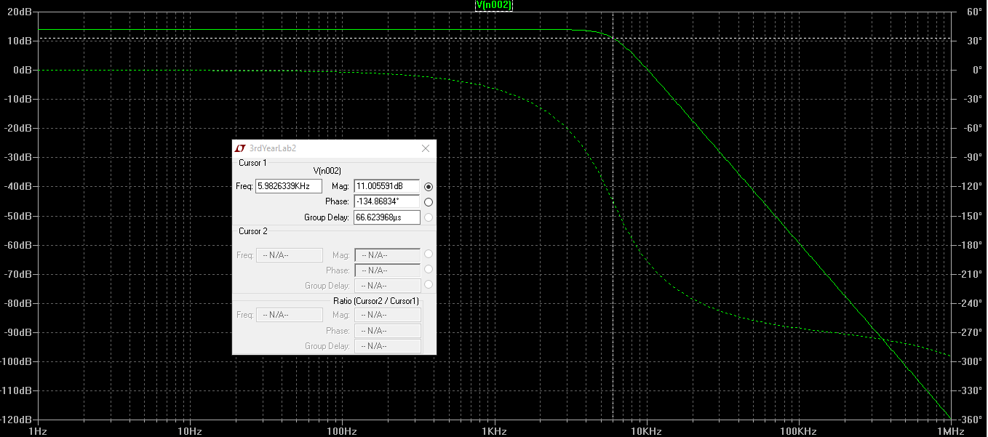5.98kHz is the frequency at which the 3dB point occurs.

## What is the phase at this frequency?

The Phase at this frequency is -134°.  
Determining transfer function and Bode plot in MATLAB.

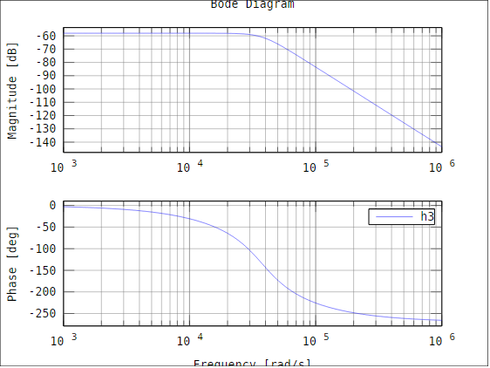

## Does the 3dB point occur at the same frequency as it did in circuit simulation?

Assuming that the max gain is -58dB the 3dB point occurs at -61dB which appears to be just before the ${4.10}^{4}$ rad/s region. Seeing as 6kHz in rad/s is ${3.78.10}^{4} rad/s$ we say that it occurs at the same frequency.

## What about the phase at this frequency?

Using similar logic as above the phase at this frequency is also the same.

# In-Lab

# Testing

|  |  |  |  |
| --- | --- | --- | --- |
| Frequency | Output in Volts | Output in dB | Phase difference in degrees |
| 10Hz | 10 | 20 | 0° |
| 100Hz | 10 | 20 | 0° |
| 1kHz | 10 | 20 | -24° |
| $$f_{c}$$ | 7 | 16.9 | -138° |
| 10kHz | 2 | 6 | -199° |
| 100kHz | 0.001 | -60 | -255° |

## At what frequency does the 3dB point occur when you test your filter? How does this compare with the cut-off frequency you designed for?

The 3dB point of our circuit occurred at 6kHz which was the exact cutoff frequency, $f_{c}$, that we designed our circuit for.

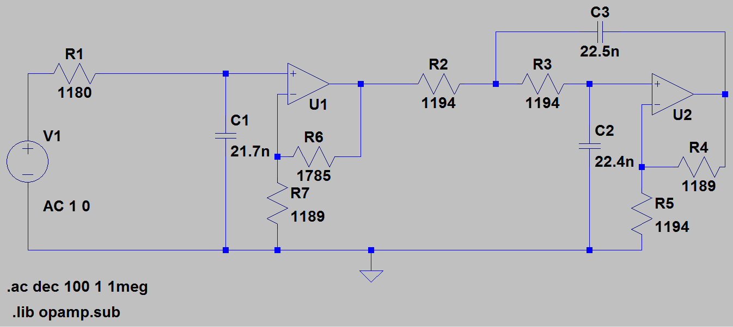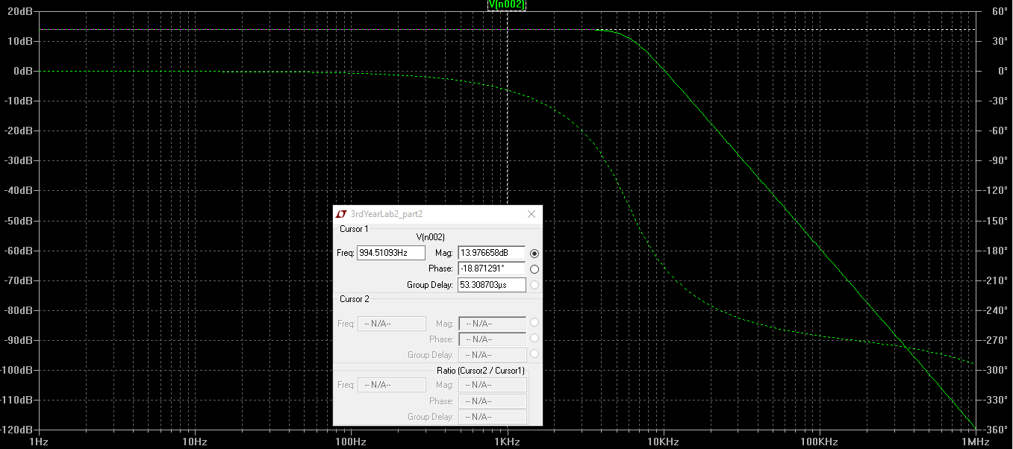  
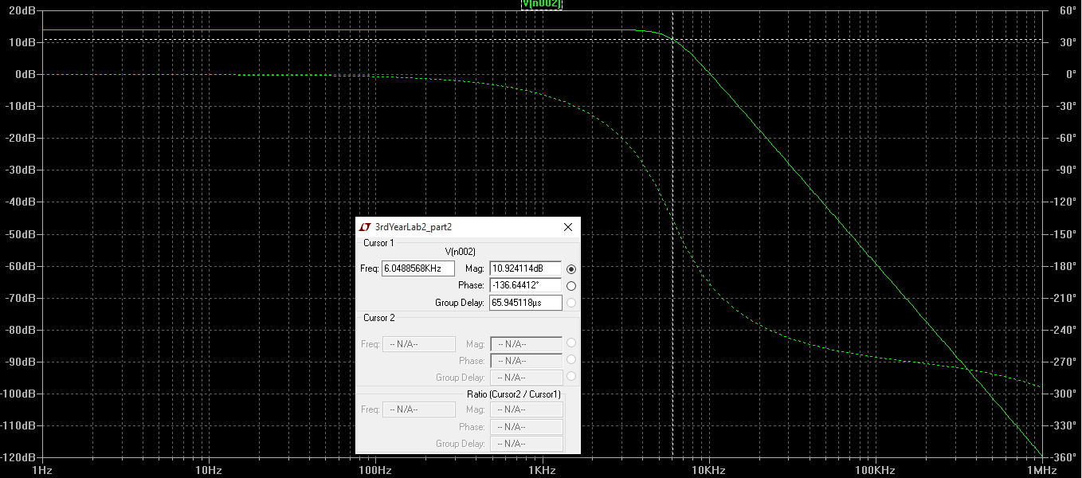

## Is there a better correspondence?

## What does this tell us about circuit theory relative to real-world implementation?

There is a better correspondence with our measured values but not with our original design. It shows that for real-world implementation you can get close to your ideal design, but that you must also allow for slight discrepancies in component values which will affect your response very slightly. However, on a whole, using similar component values to those in your theoretical design for your real-world circuit will give you an incredibly close response and will work in practice.